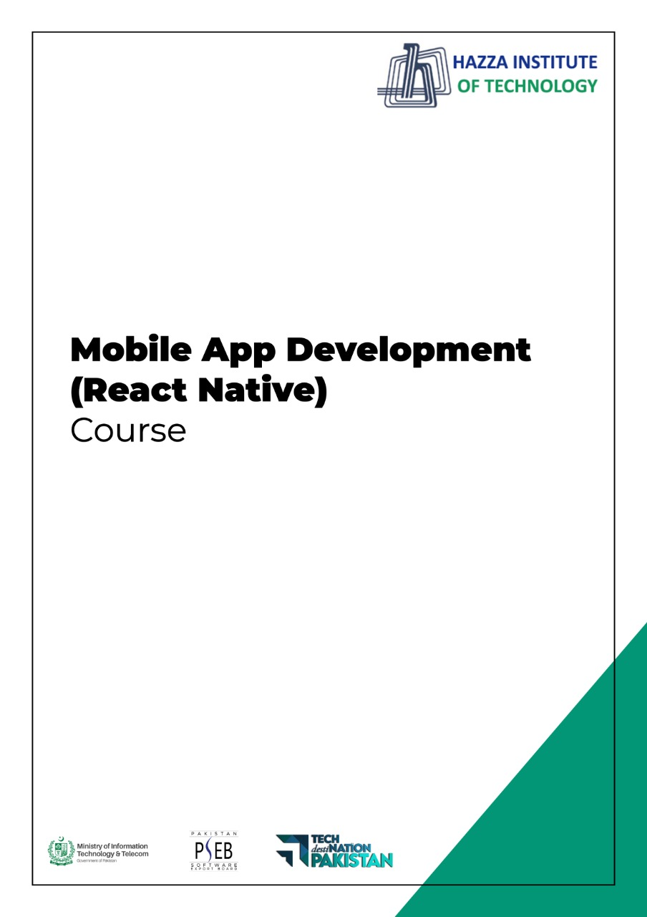
(Flutter)
Lab 15

Total Time:
3 hours

Pre-Lab Activities:

  - Familiar with Flutter Firebase

Learning Outcomes:
  - Student will learn how to create a complete todo app using firebase.

Student Activities:
  - create firebase project
  - configure it in Android project
  - integrate firebase auth
  - integrate firebase firestore
  - integrate firebase storage

Lab Tasks 1:
  - Create login screen
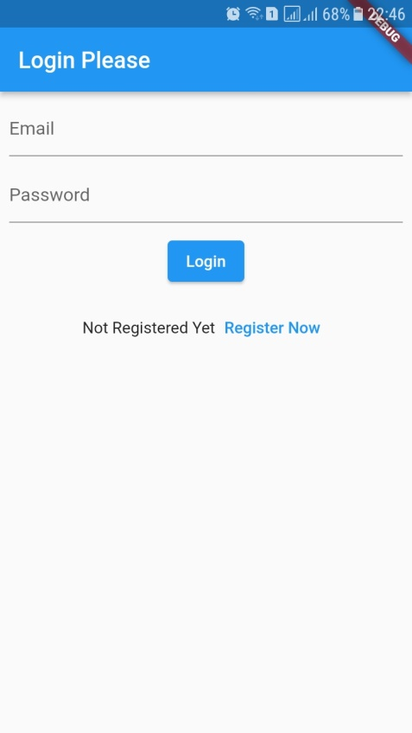

Lab Tasks 2:
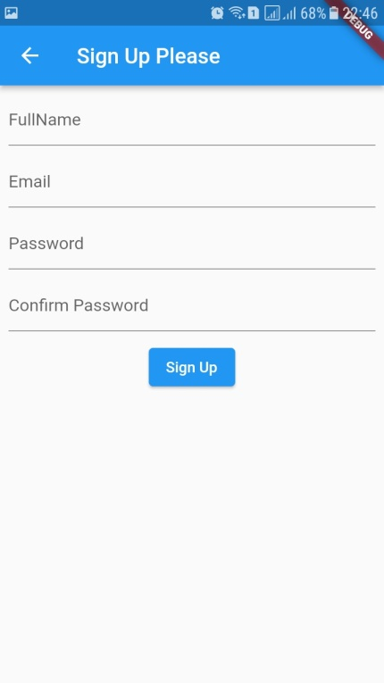
  - Create a Sign up page shown below, on click of registration button it must register user in firebase auth and also store data in firebase firestore.

Lab Tasks 3:
  - After successful login, display TaskListScreen
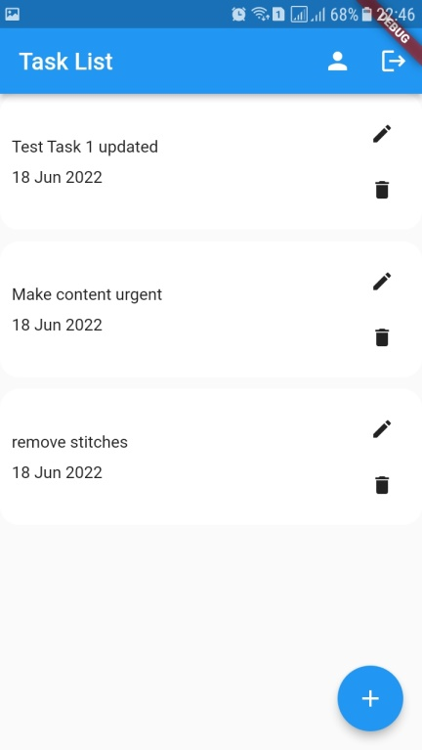

Lab Tasks 4:
when floating action button is pressed, open a new screen ( AddTaskScreen )
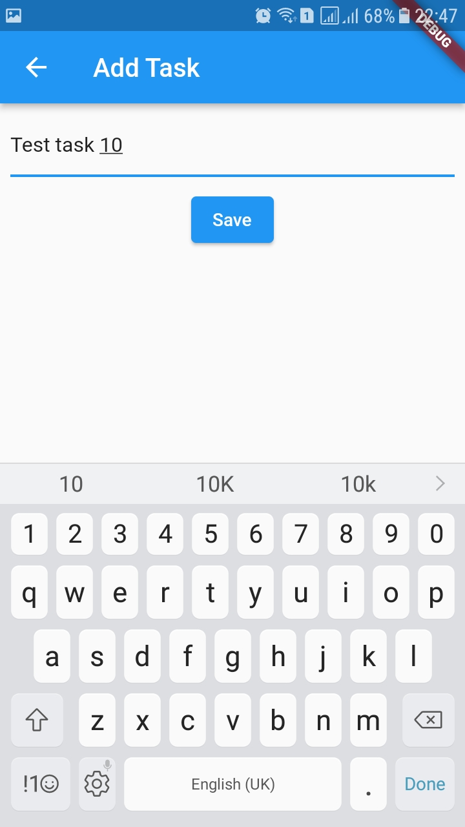

Lab Tasks 5:

When delete icon on TaskListScreen is pressed, show AlertDialog and then delete the task
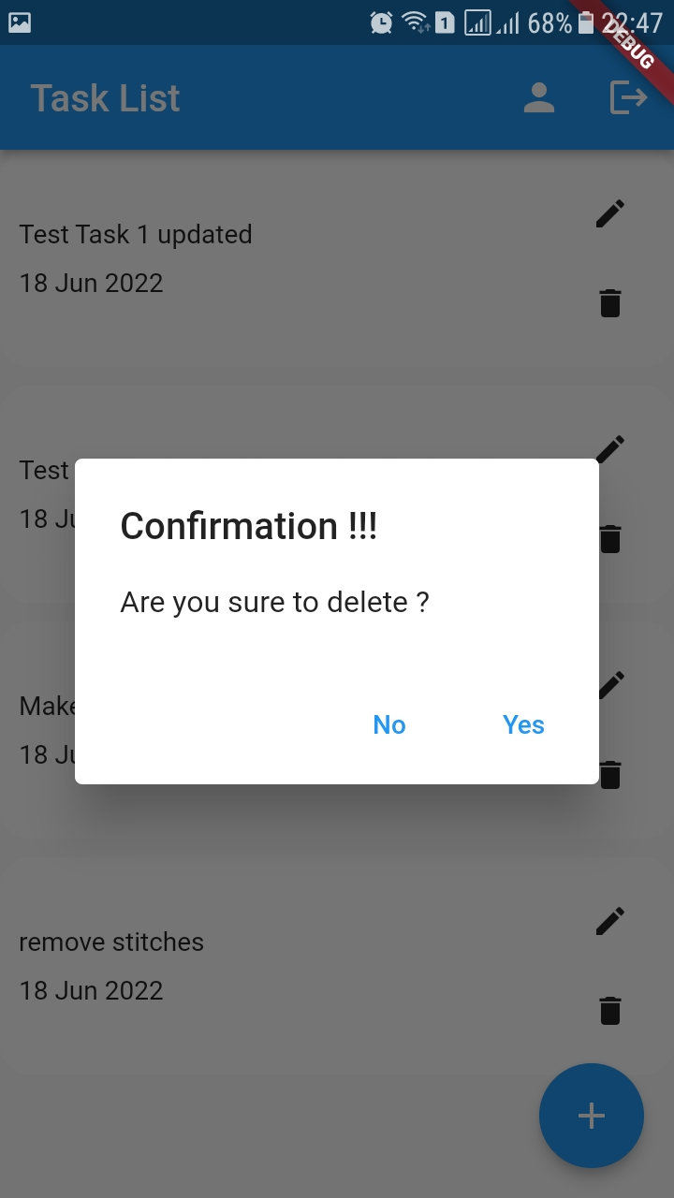

Lab Tasks 6:
When edit option is pressed on the TaskListScreen, open a new screen with the task to be updated
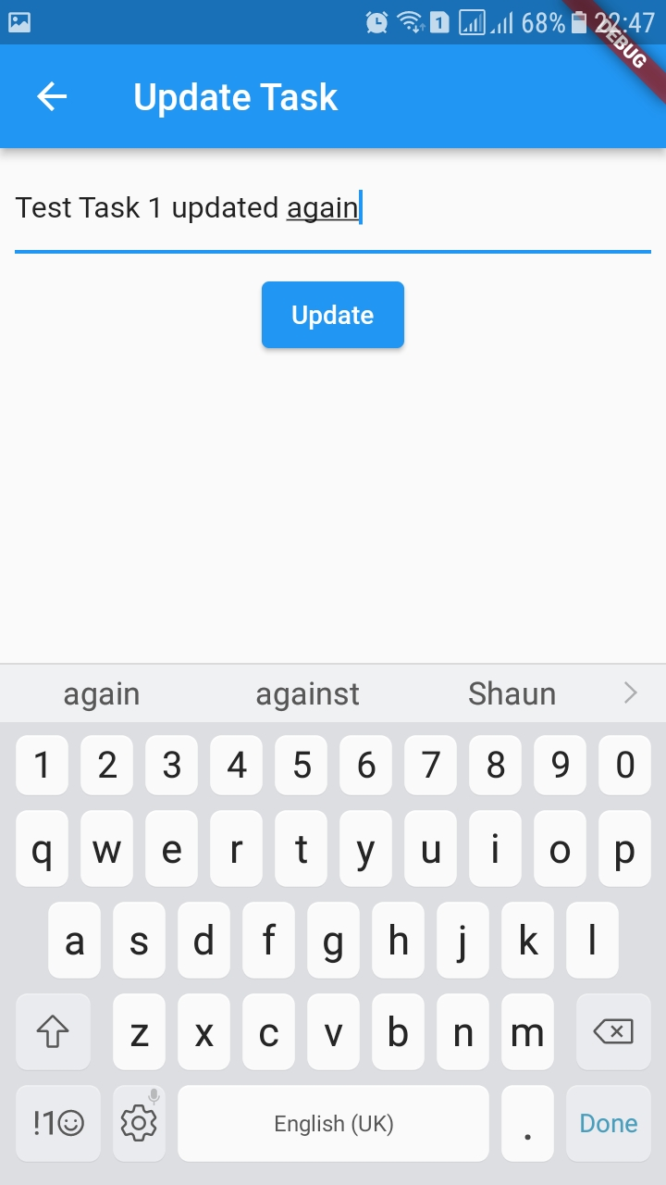

Lab Tasks 7:
When profile icon in the appBar is pressed, open User Details screen
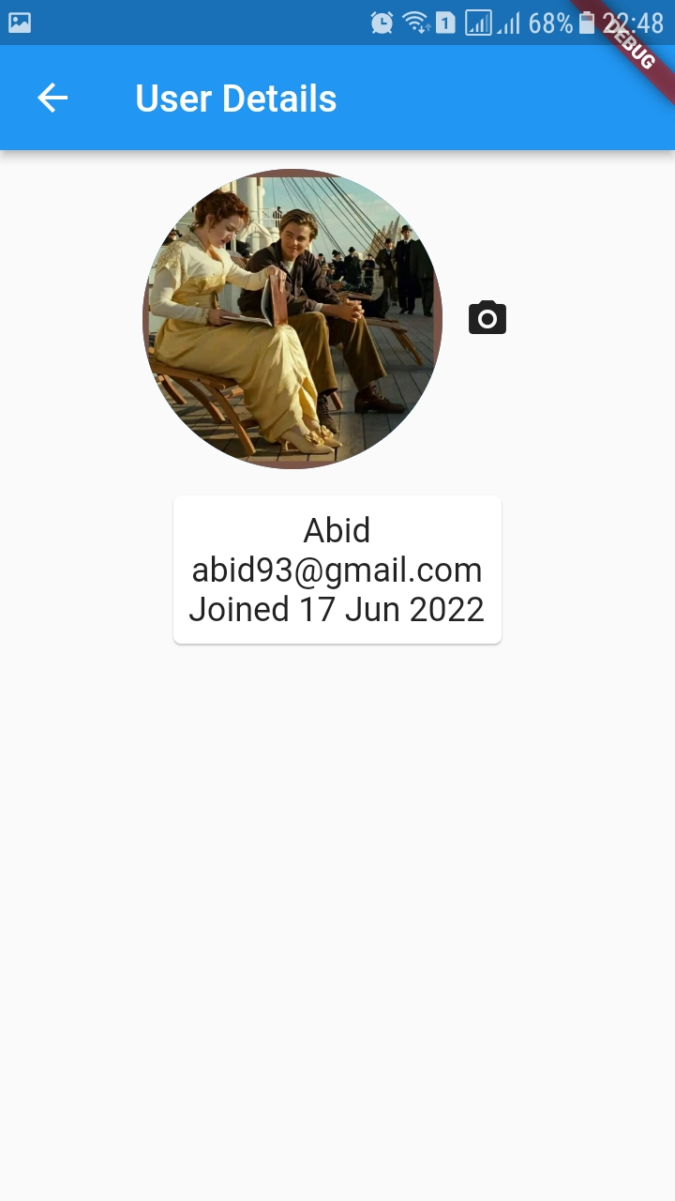

Lab Tasks 8:
When the camera icon button is pressed, show a bottom sheet
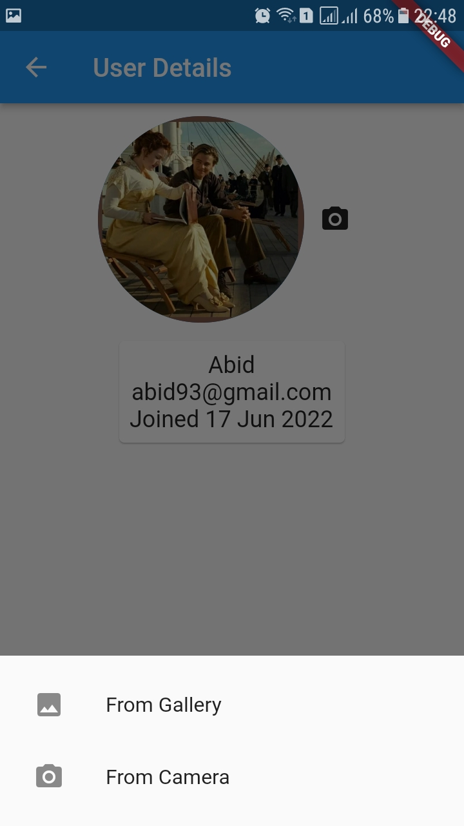

Lab Tasks 9:
Depending on the selection, upload the image to firebase storage and also update the user in firestore
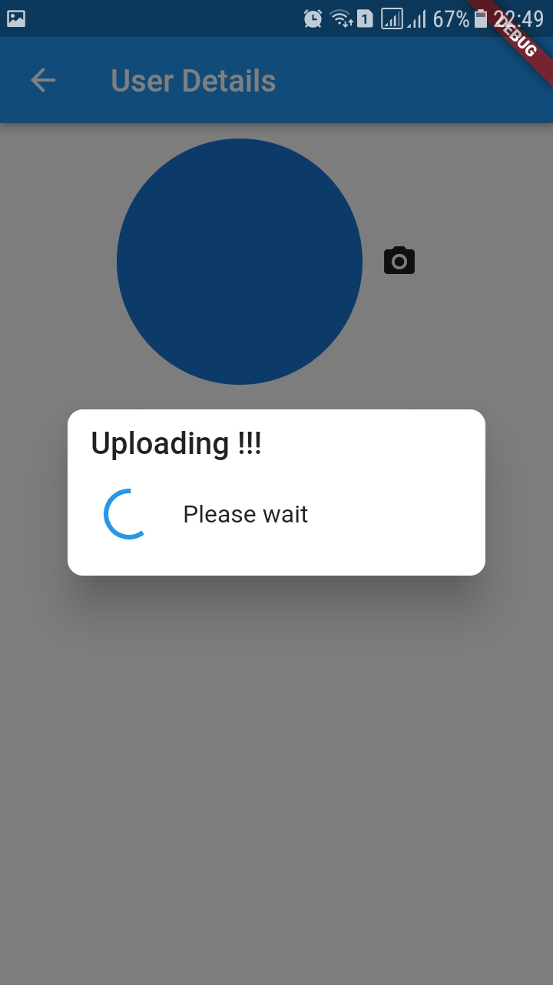

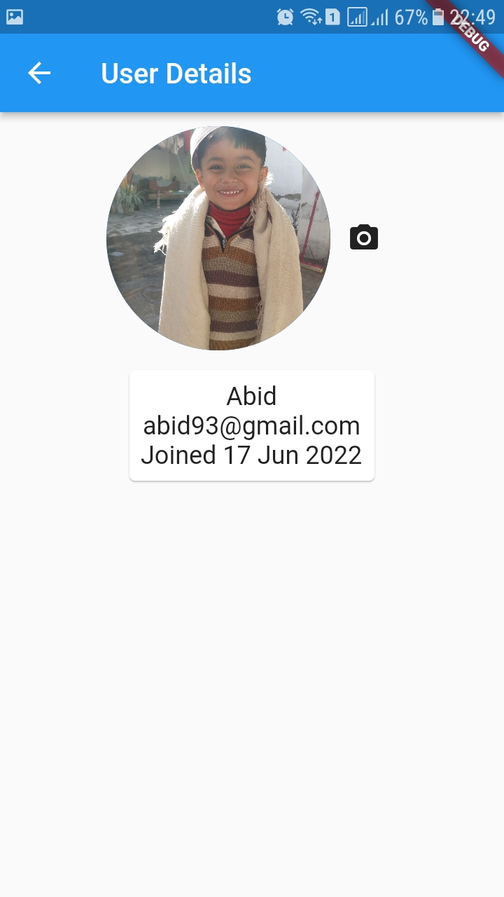

Lab Tasks 10:
When the logout button is pressed in the appBar action, show a confirmation and dialog
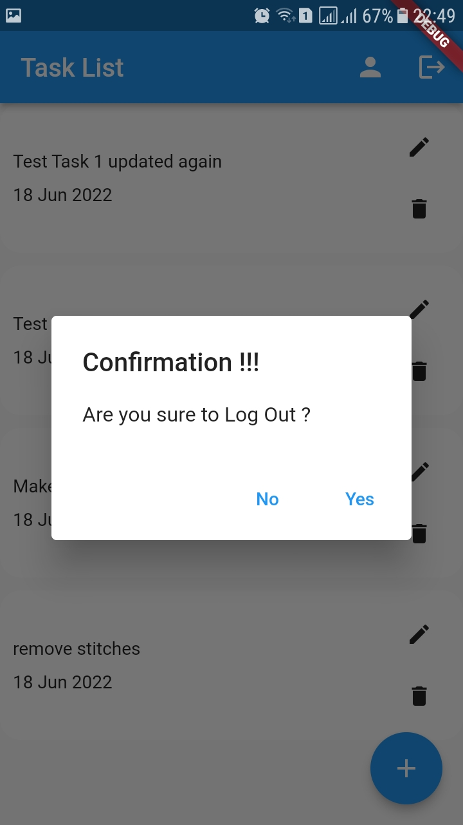

Implementing the whole logic of the app

Whether you’re working a simple to-do application or building your dream app, authentication helps you personalize the experience with user-specific information. It’s also a crucial component for privacy and security.
Firebase Authentication is a preconfigured backend service that makes it really easy to integrate with a mobile app using an SDK. You don’t have to maintain any backend infrastructure for the authentication process and Firebase supports integration with popular identity providers such as Google, Facebook, and GitHub.
In this tutorial, we’ll show you how to integrate Firebase Authentication with your Flutter app. To demonstrate with a practical example, we’ll walk you through the process of building an email-password registration and login process.
We’ll walk through the following steps:
- Create a Flutter and Firebase project
- Set up Firebase for Android, iOS, and web
- Import Firebase plugins
- Initialize Firebase App
- Register a new user
- User sign-in and sign-out
- Refresh user
- Define validators
- Build the sign-in form
- Build the profile page
- Persist the login state
*Note: Complete source code available at
- https://github.com/abidroid/todo_flutter_app_pseb_bridge

